Task 1: Creating a virtual machine
Step 1: Filling in the basic details for creating a virtual machine
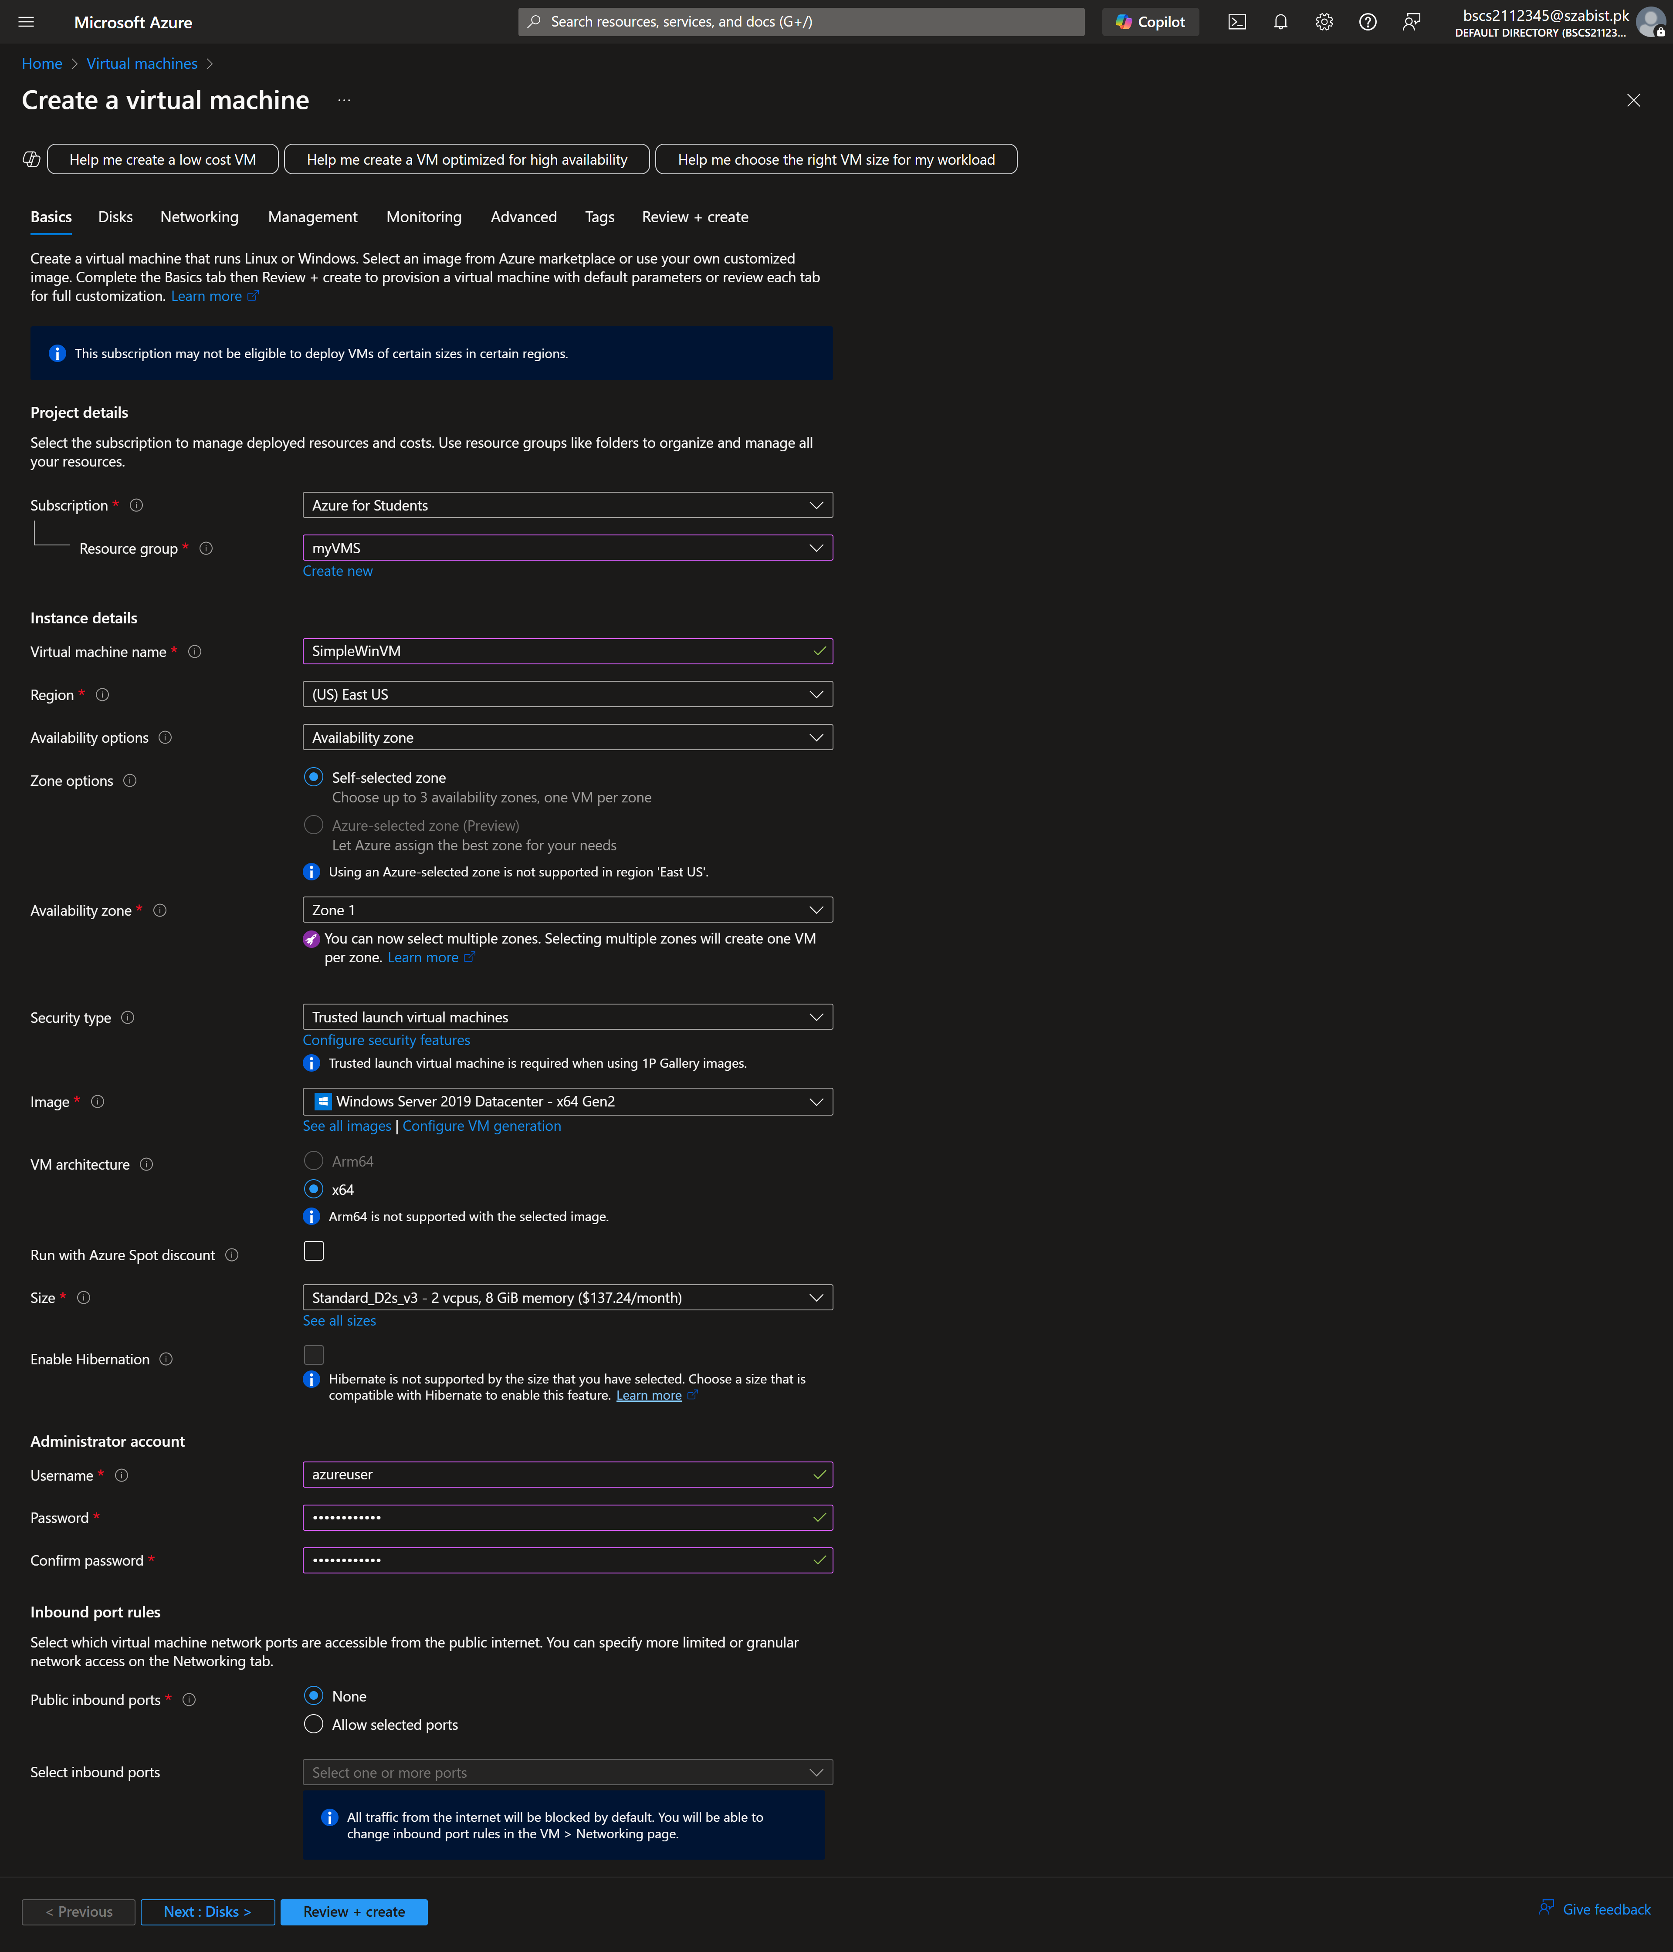

Step 2: Configuring network settings, selecting “None” as the NIC network security group.
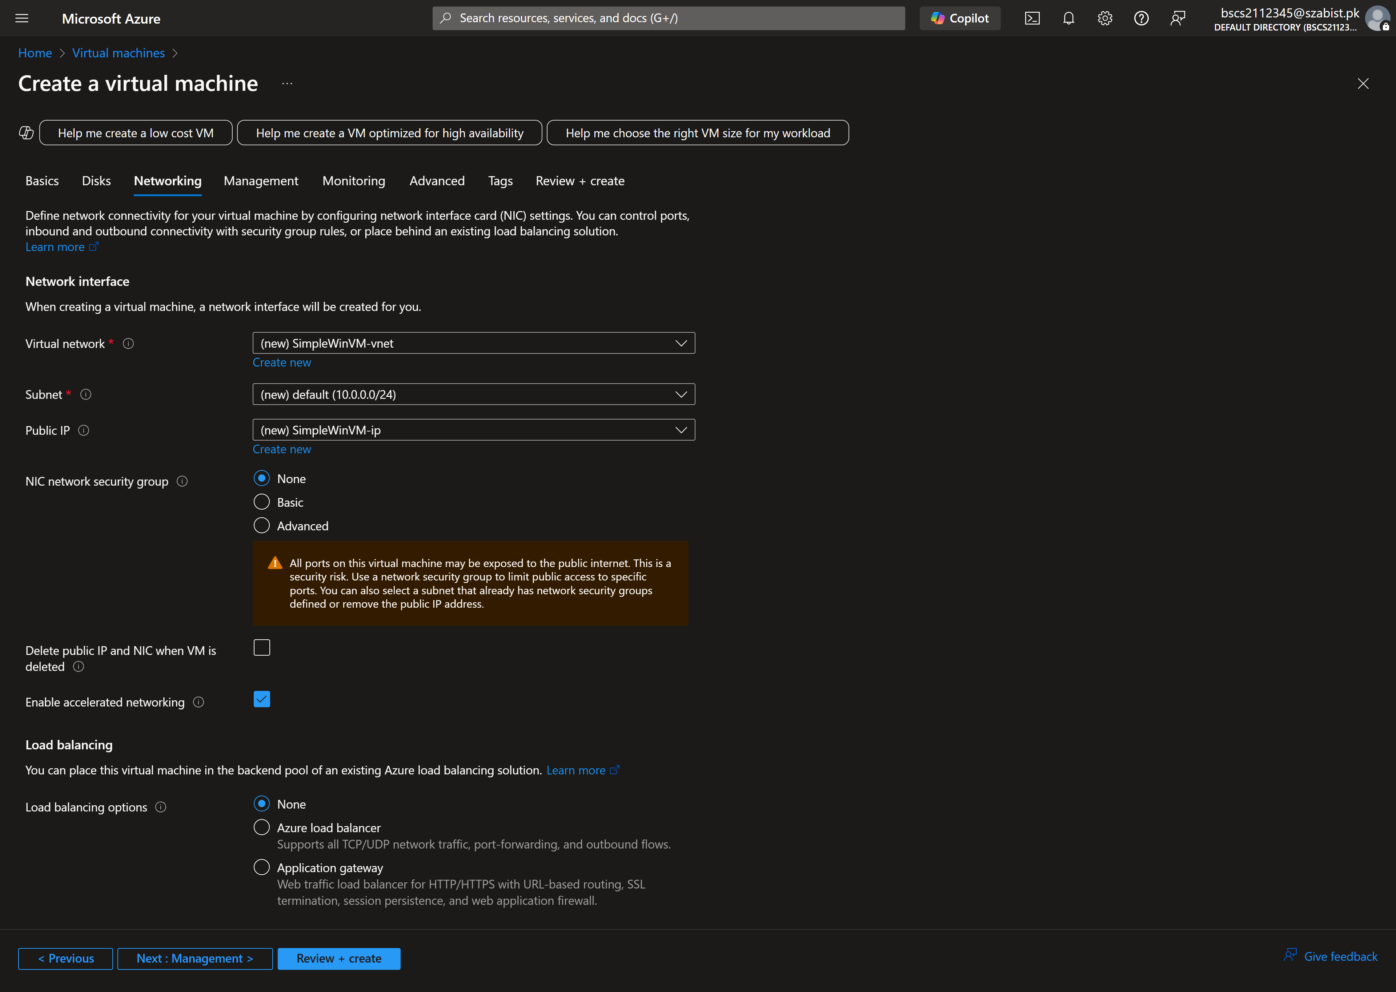
Step 3: Disabling the boot diagnostics in Monitoring tab for the virtual machine
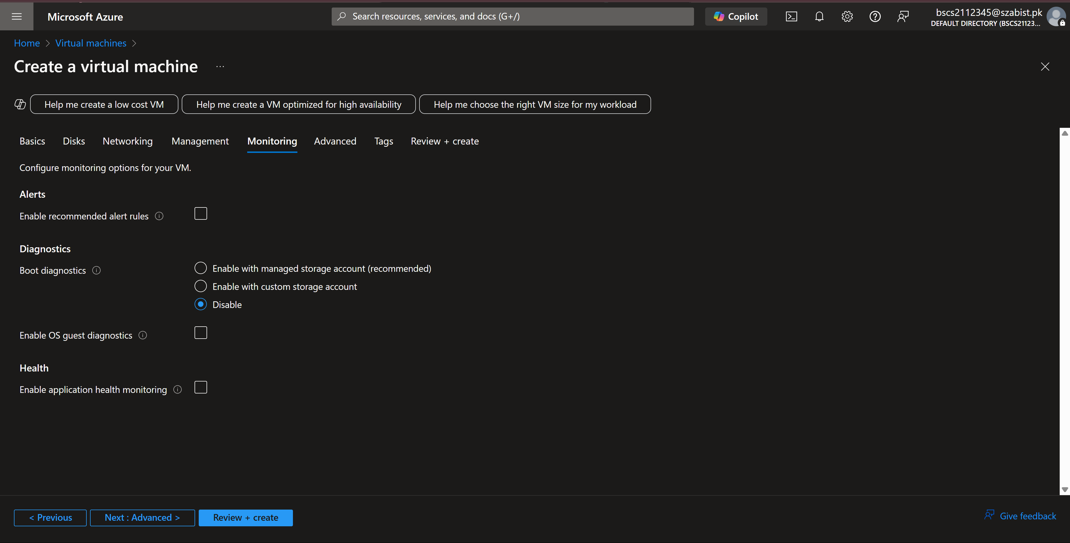
Step 4: After completing the configuration, the below image displays the complete overview of the configuration and message saying validation checks passed
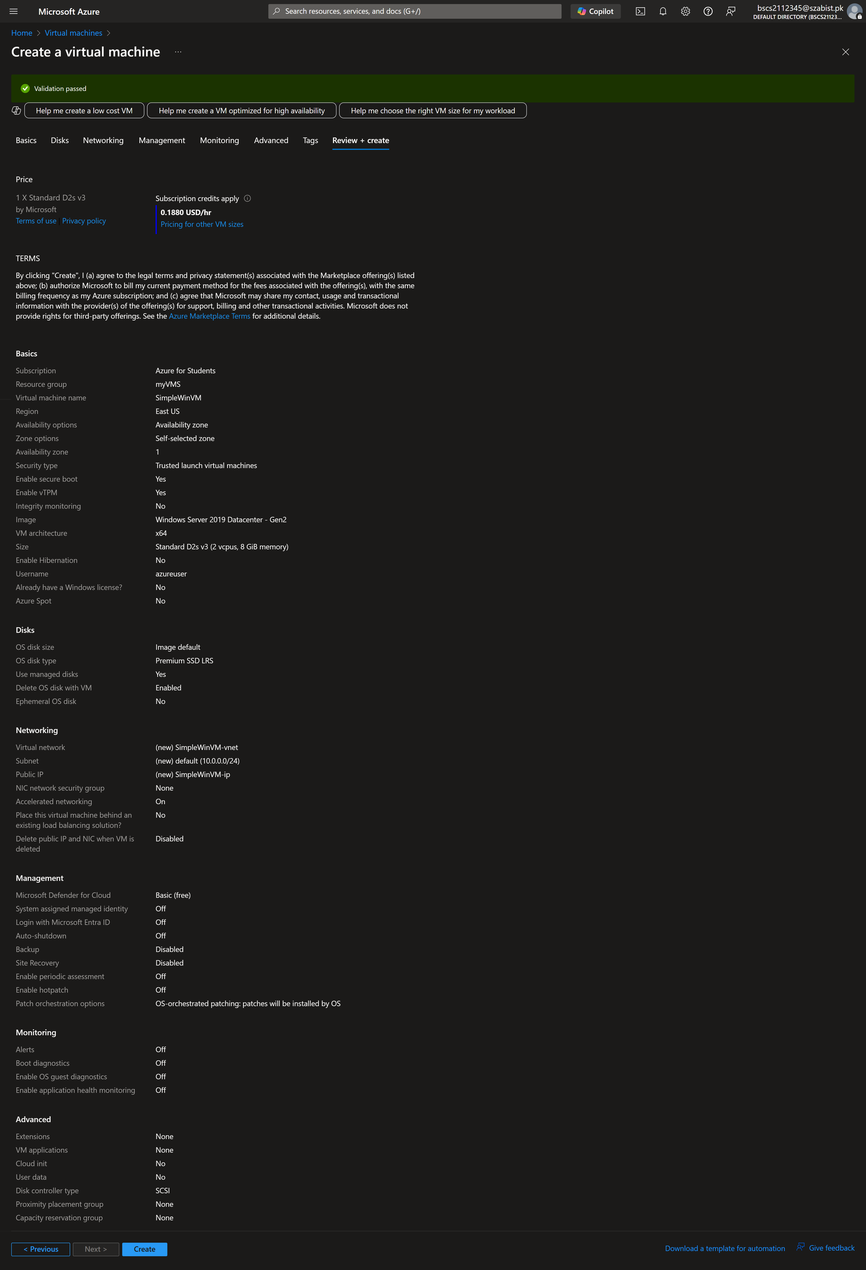
Step 5: Displaying the network settings of the VM after successful creation to verify no network security group is assigned
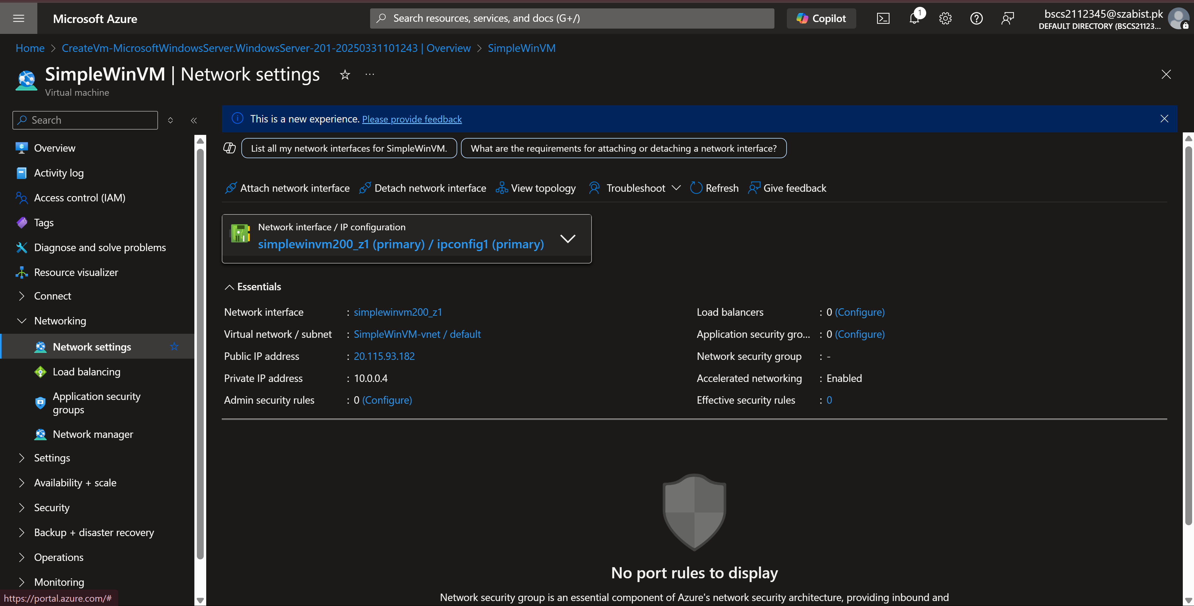

Task – 2: Creating a Network Security Group
Step 1: By searching network security groups(NSG) in the search bar we retrieve the list of NSG’s where we click on create to add a new NSG. Below screenshot shows that I’ve populated the resource group and the name for the NSG
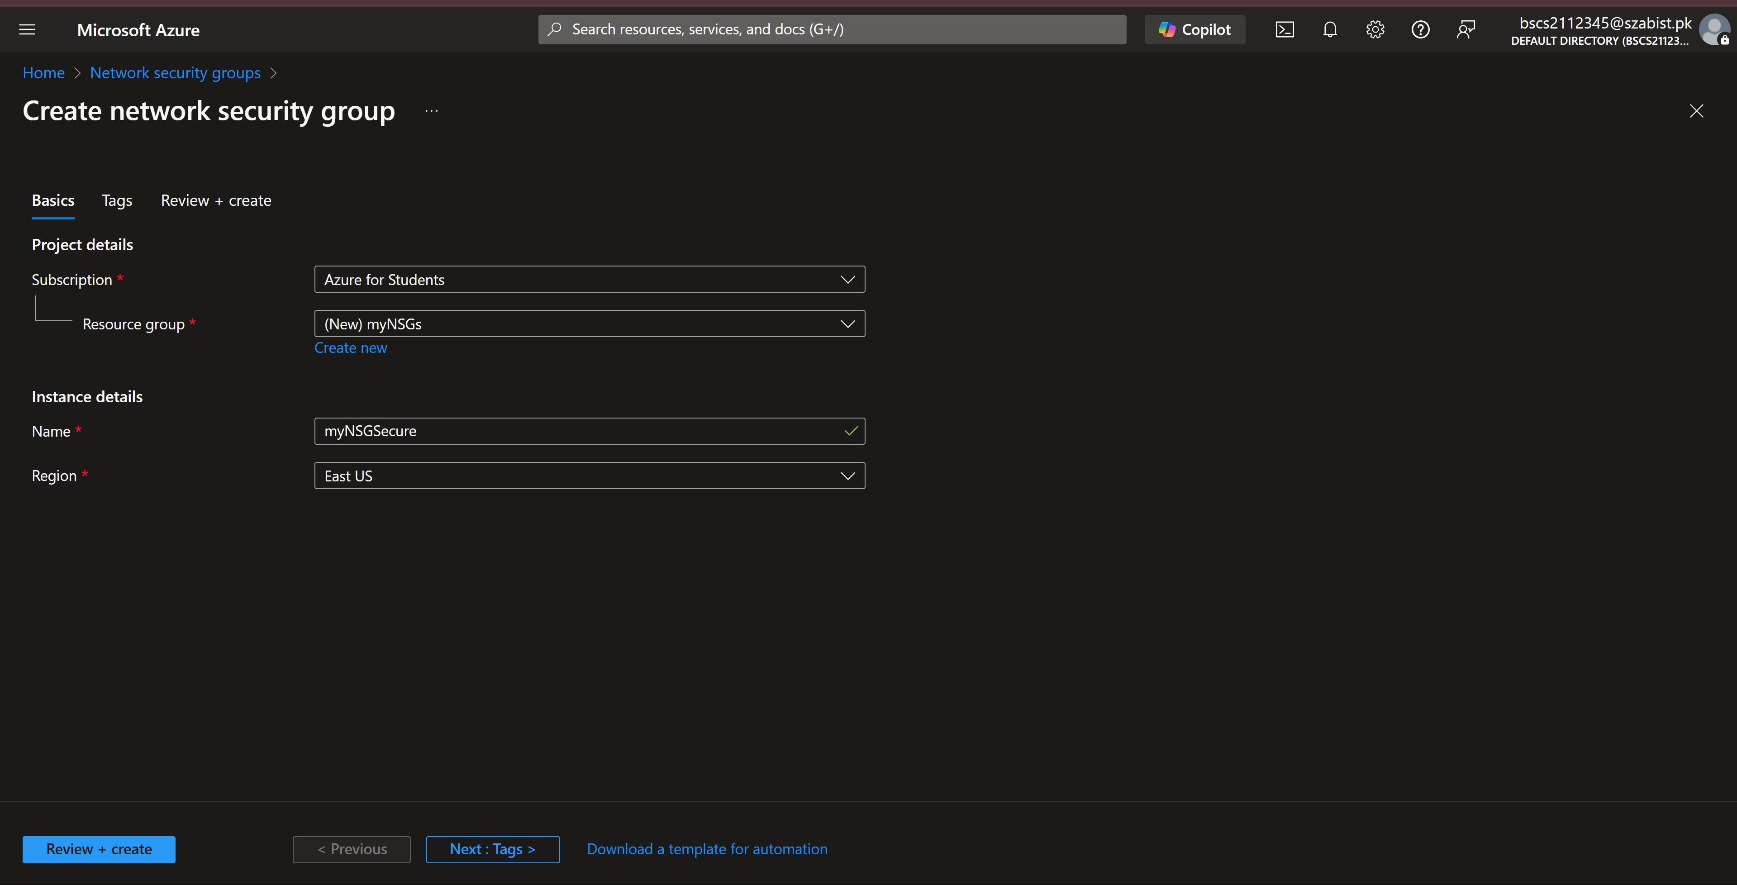
Step 2: After creating the NSG, in this step we associate it to the network interface of the virtual machine created in task 1.
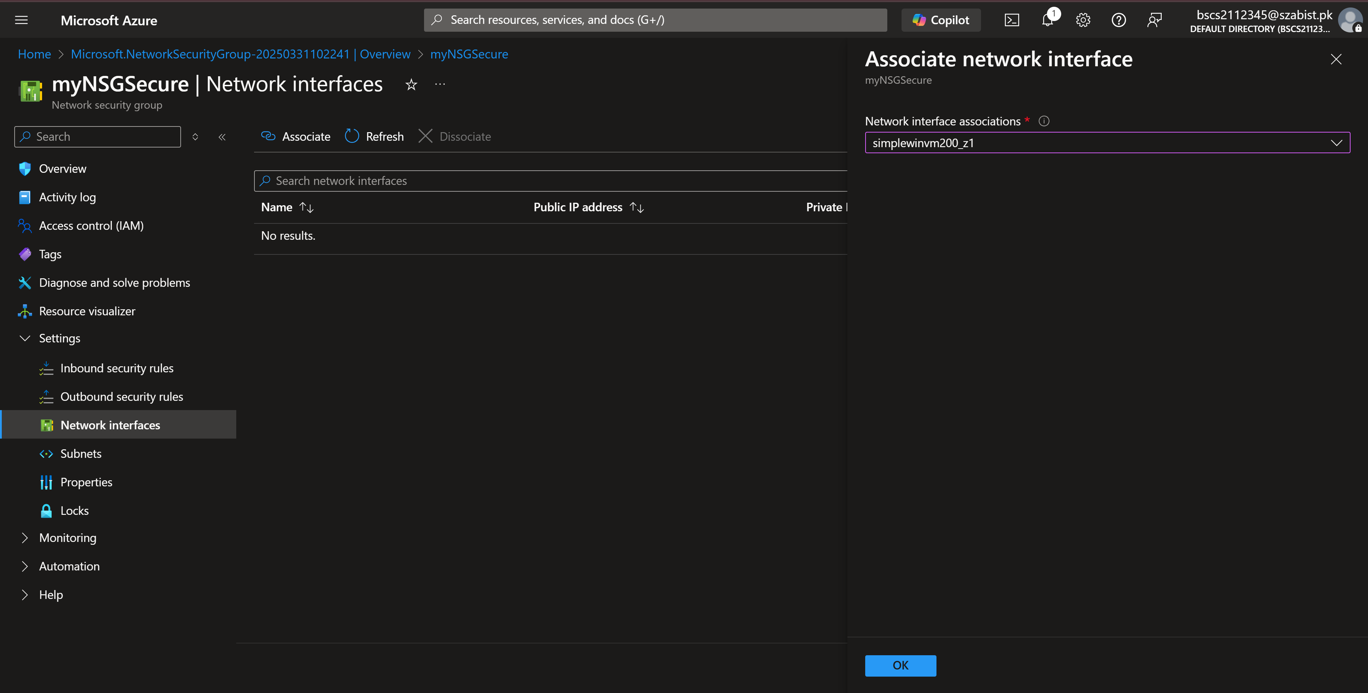
Step 3: Confirming the new association to VM’s Network interface has been added.
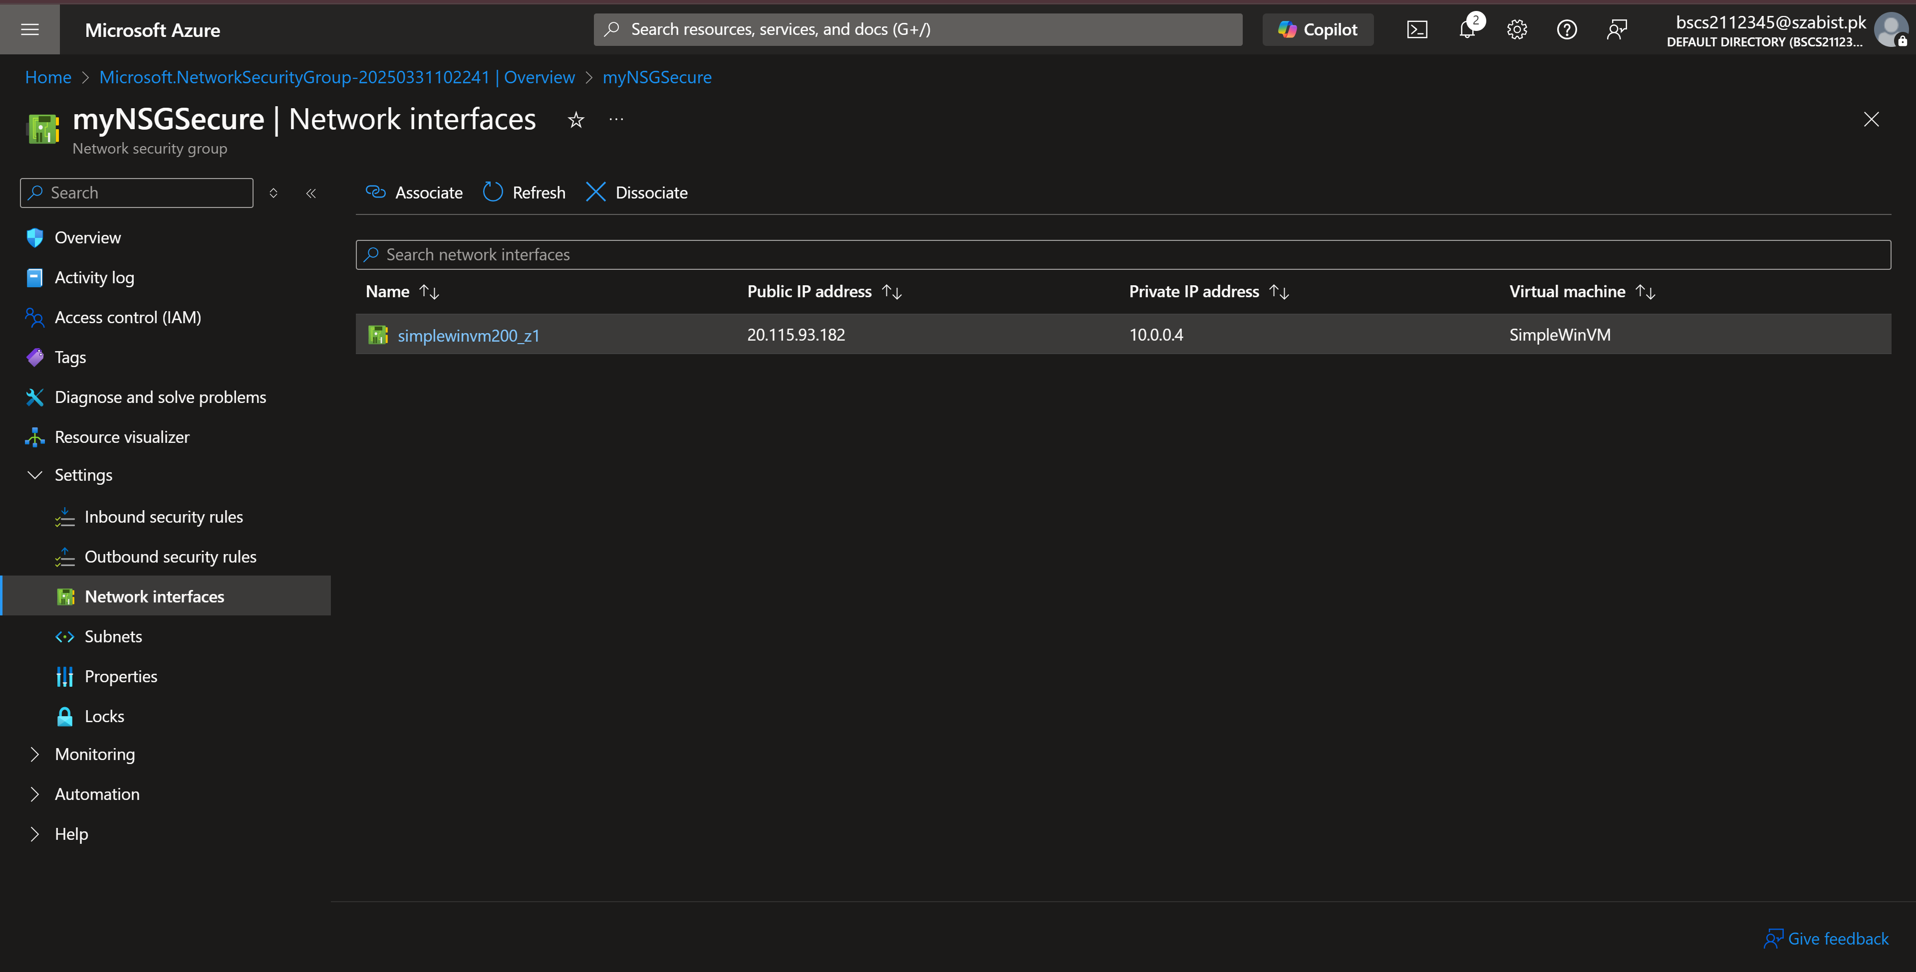

Task – 3: Configure an inbound security port rule to allow RDP
Step 1: In this step we try to connect to the VM by downloading the RDP file, however as we have assigned the NSG, it blocks/denies all requests, hence the error below.
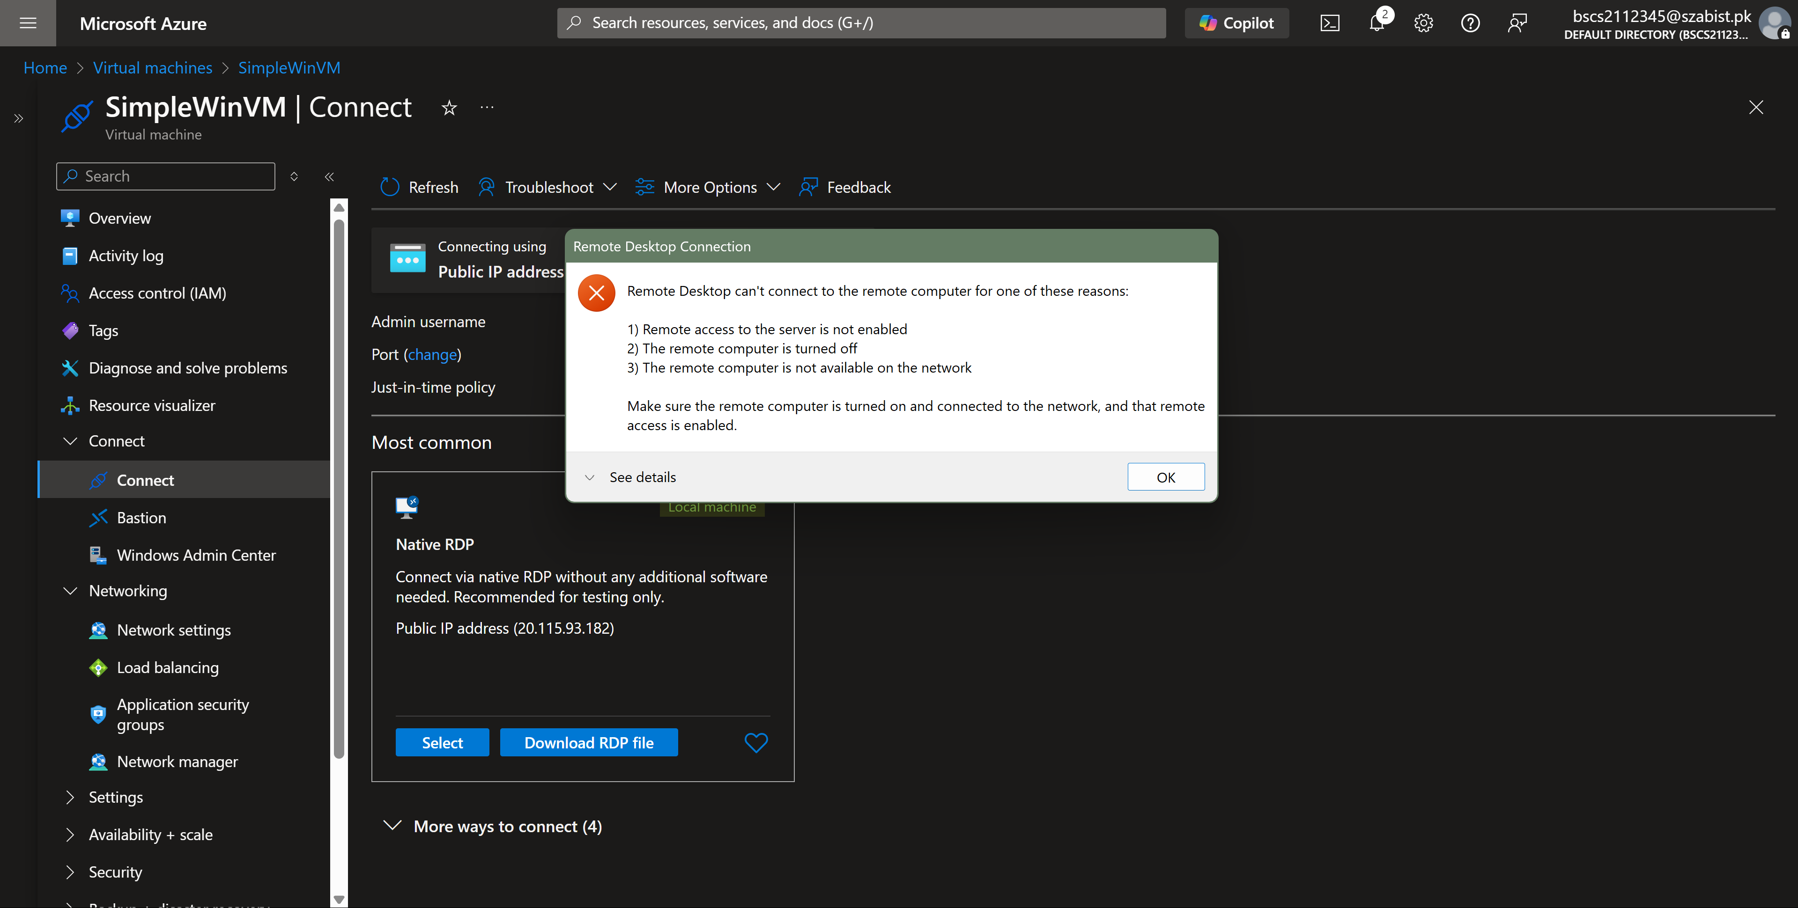
Step 2: Displaying the current network settings of the VM and it’s inbound port rules. By clicking on “Create port rule” we can add a inbound and outbound rule.
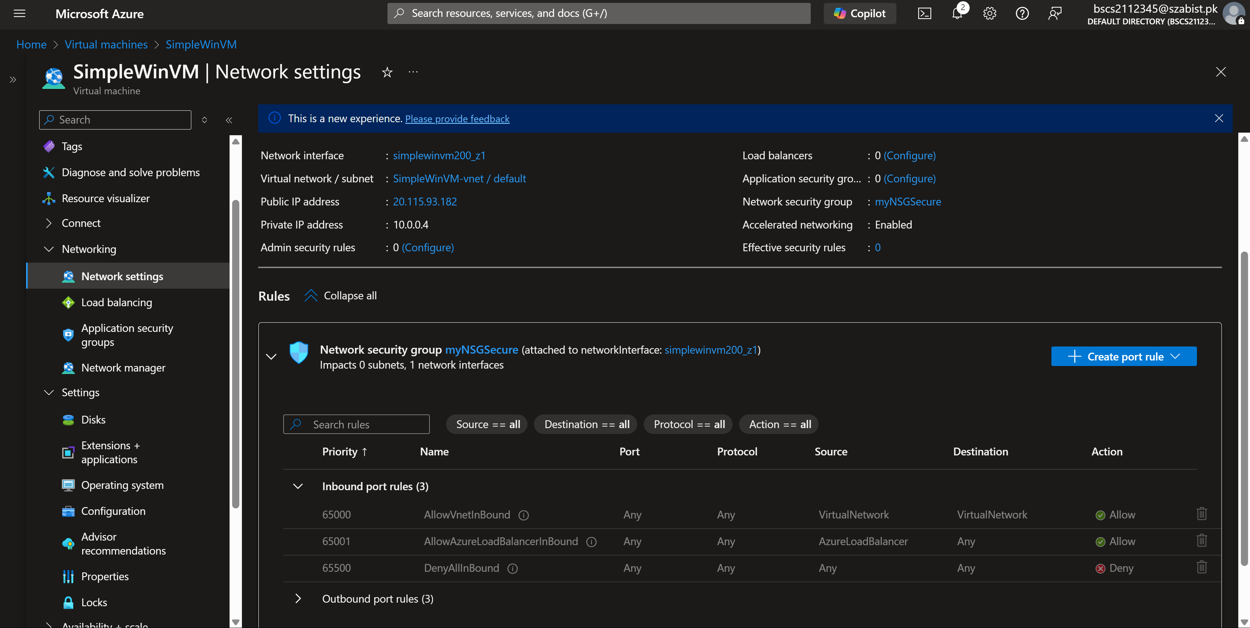

Step 3: In this step I’ve added a inbound security rule to allow RDP traffic and set it’s priority to 300.
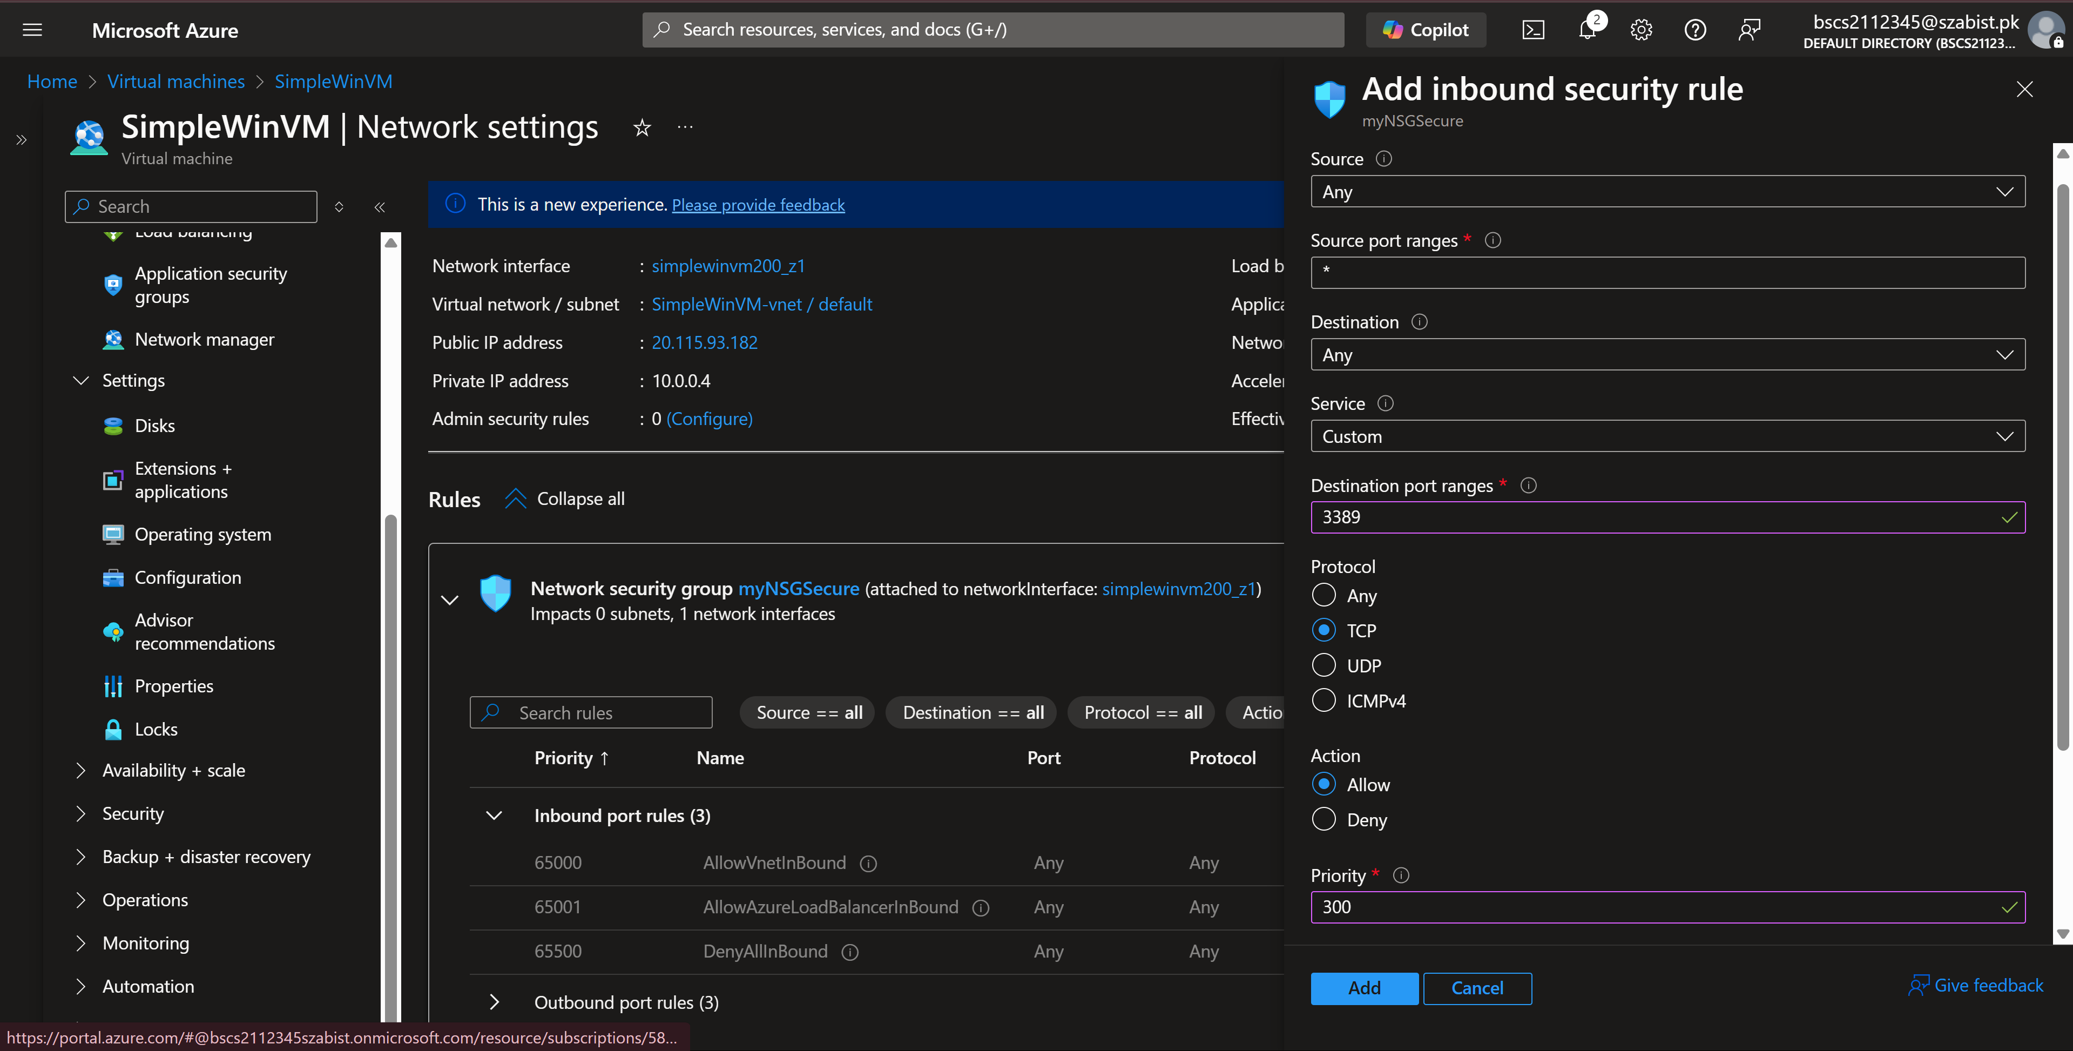
Step 4: After adding the inbound rule, I’ve accessed the VM through the same RDP file I downloaded in the previous steps.
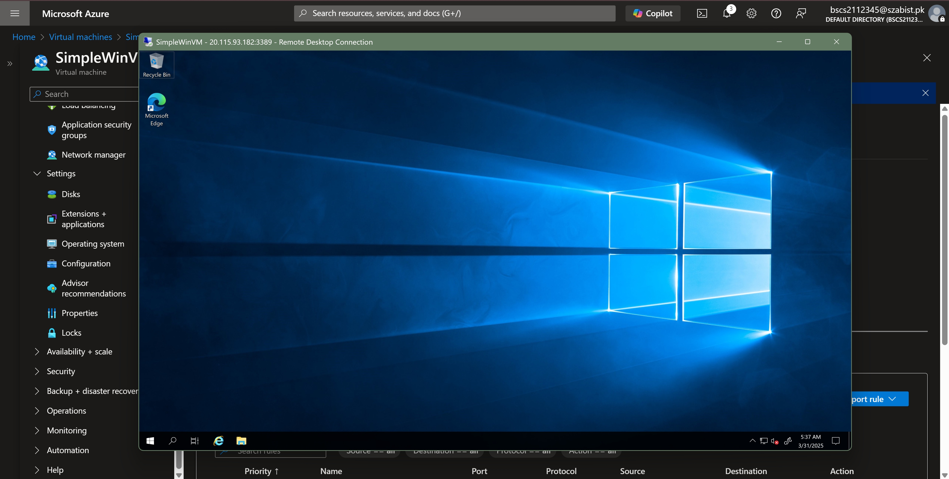

Task – 4: Configure an outbound security port rule to deny Internet access
Step 1: Confirming internet access is allowed on the VM by visiting www.bing.com in internet explorer
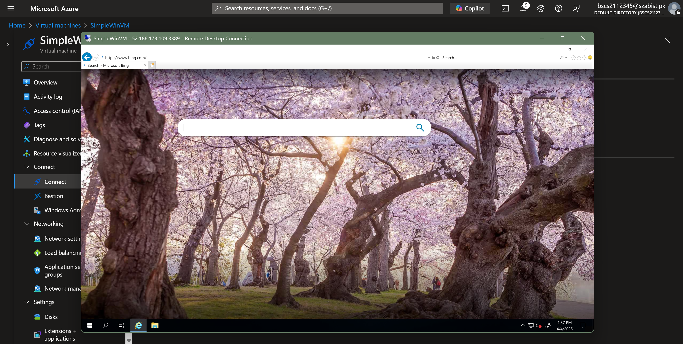
Step 2: Implementing outbound deny rule to restrict internet access inside the VM
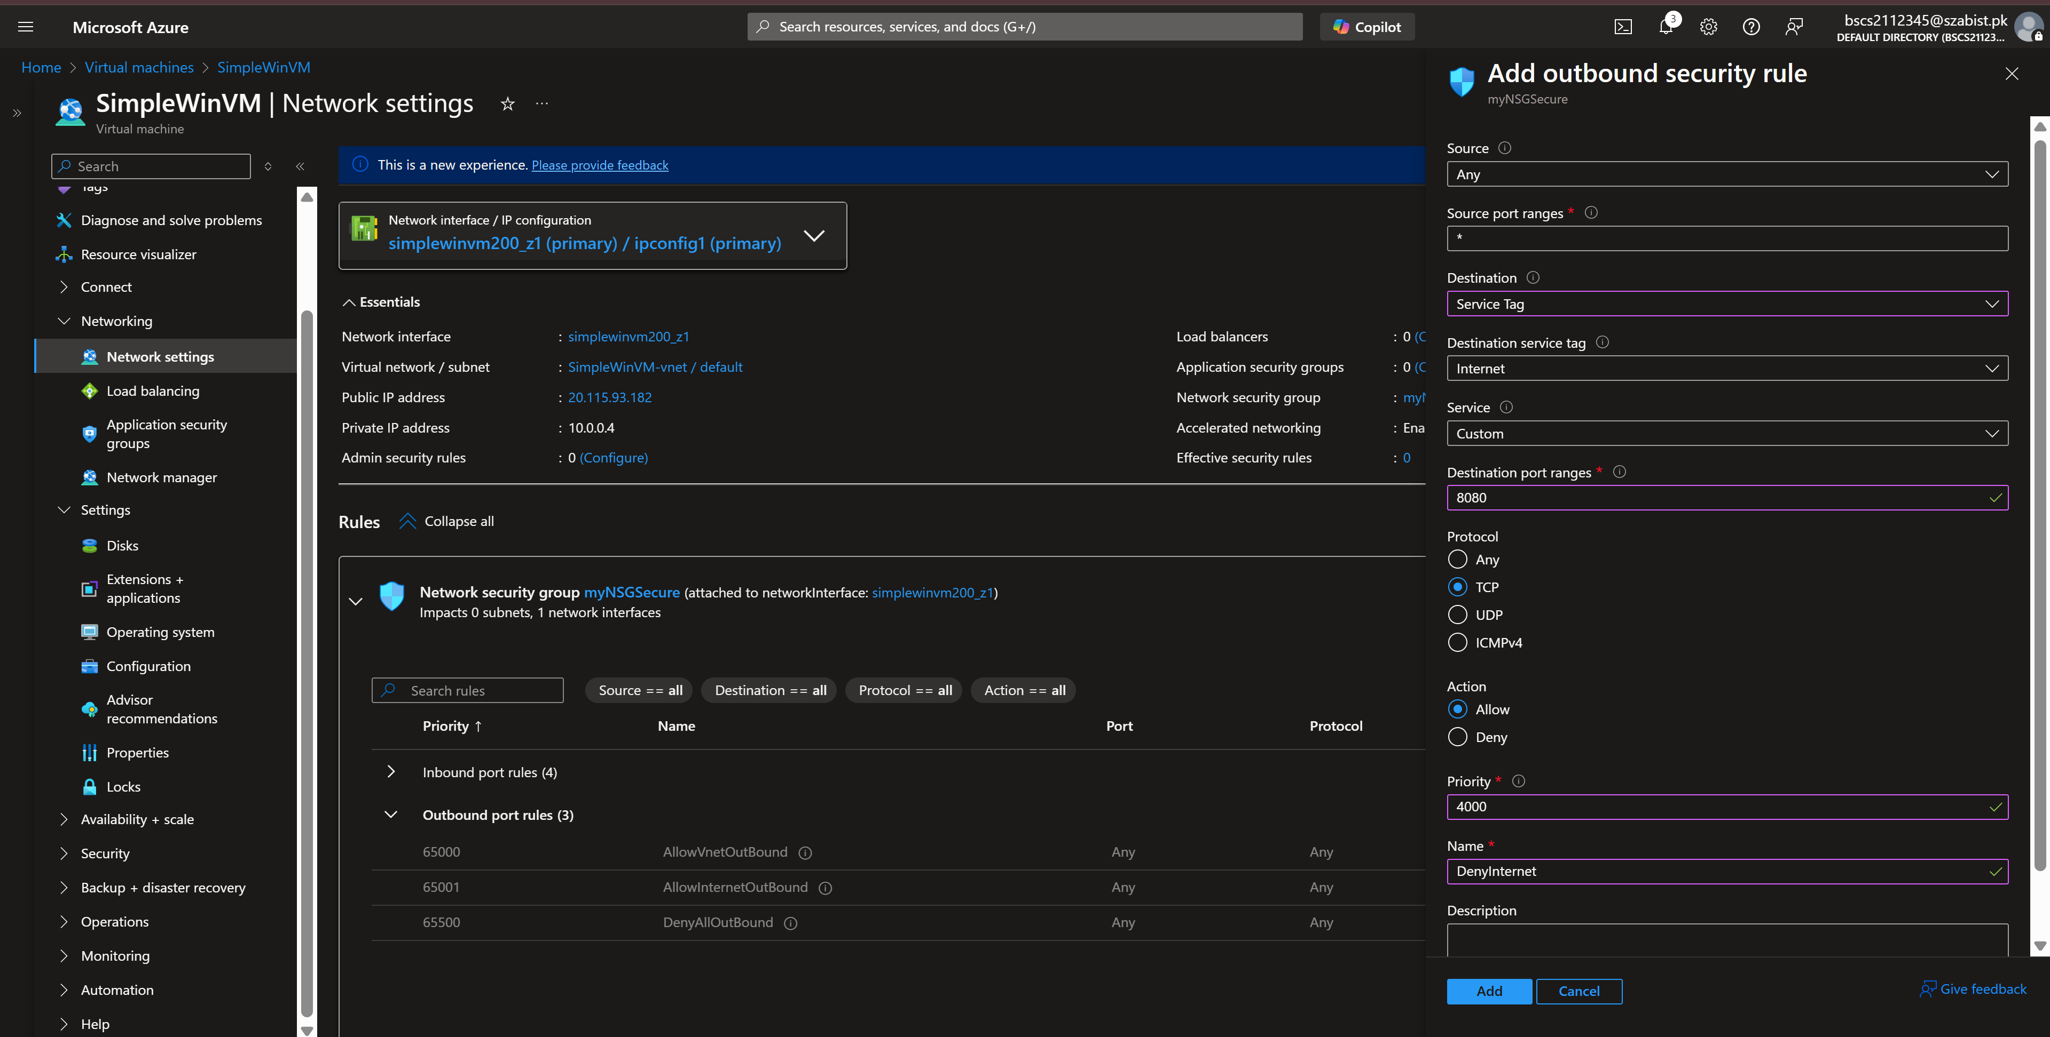

Step 3: After adding the outbound rule, we can confirm that the internet access has been restricted and is available.
